**STEP 1: CREATING AWS, INSTALLING APACHE AND UPDATING THE FIREWALL**

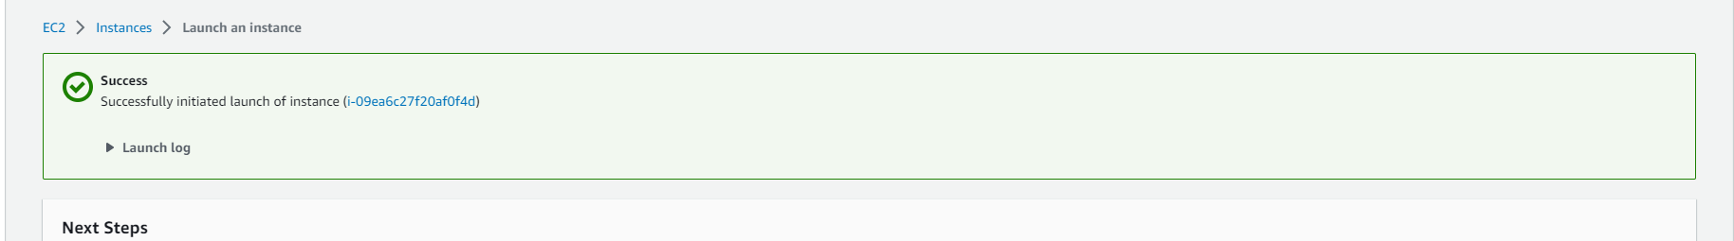

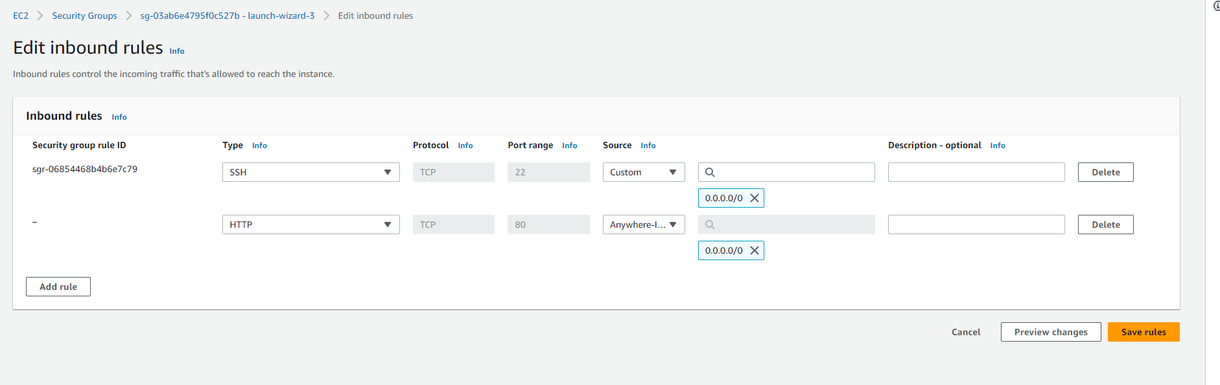

Connected to my AWS server via terminal, suing the commands below.

Cd downloads

ssh -i "project1.pem" ubuntu@ec2-52-54-249-245.compute-1.amazonaws.com

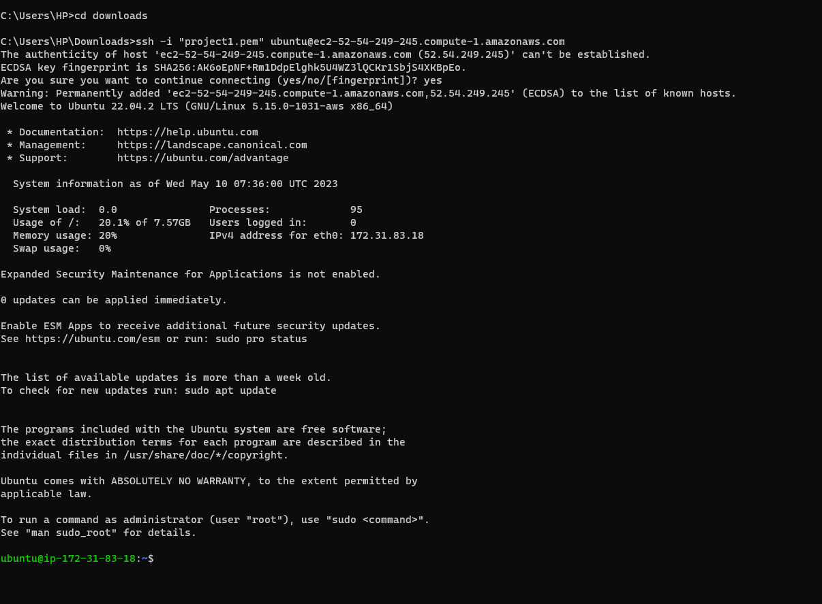

I updated the packages on my server using the command

sudo apt update.

I installed apache2 on my server, the reason for installing apache2 is because apache1 is no longer in existence.

Sudo apt install apache2

To verify that apache2 is running as a Service, I ran

sudo systemctl status apache2

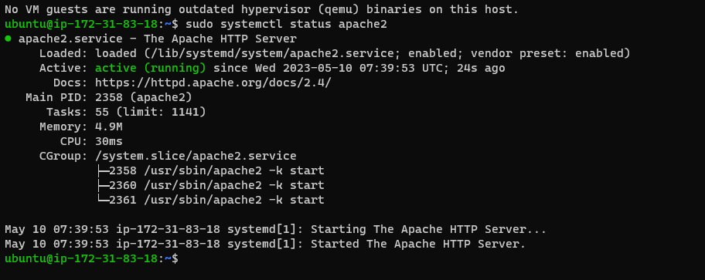

To verify that the apache2 is running, I went to my browser and pasted

<http://52.54.249.245:80>

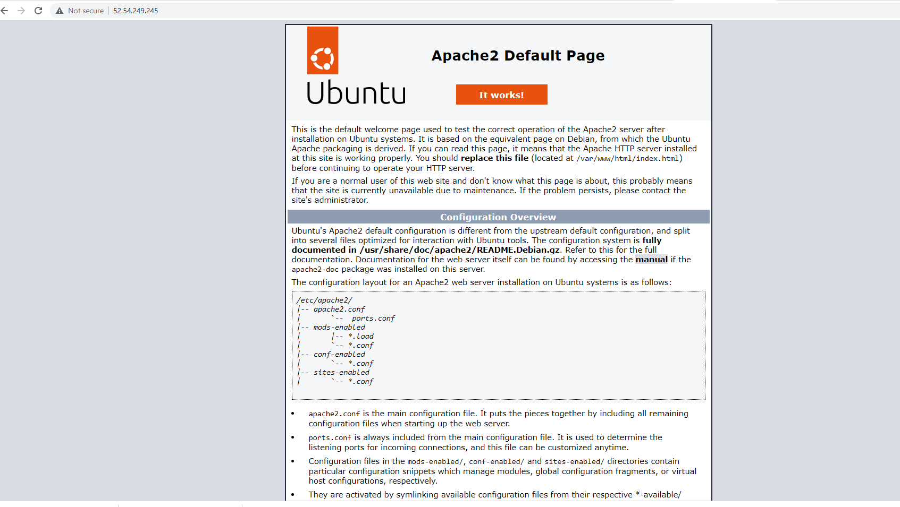

**STEP 2: INSTALLING MYSQL SERVER**

To install mysql server: sudo apt install mysql-server

During installation of mysql server

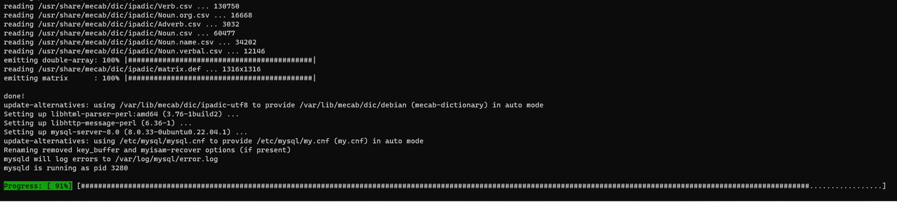

When the installation is finished, log in to the MySQL console by typing: sudo mysql

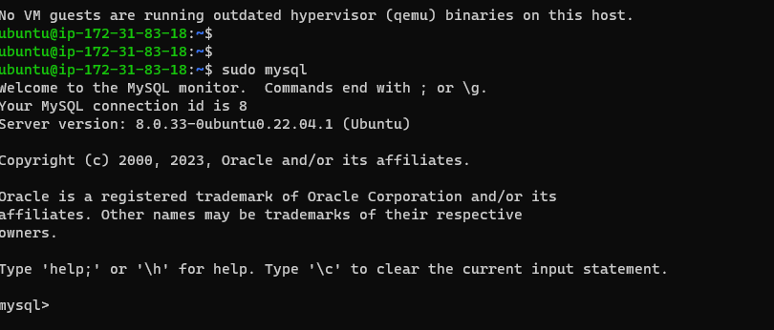

The command below removes some insecure settings and locks down the mysql database.

ALTER USER 'root'@'localhost' IDENTIFIED WITH mysql_native_password BY 'PassWord.1';

**STEP3: INSTALLING PHP**

I used the command below to install three packages at the same time. php-mysql, a PHP module that allows PHP to communicate with MySQL-based databases, libapache2-mod-php to enable Apache to handle PHP files and core PHP packages will automatically be installed as dependencies.

sudo apt install php libapache2-mod-php php-mysql -y

I ran the below command to verify the php version.

php -v

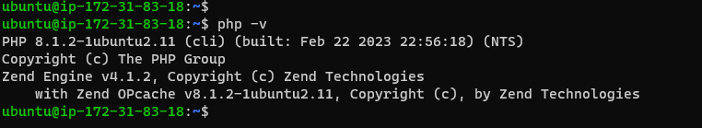

**STEP 4: CREATING A VIRTUAL HOST FOR YOUR WEBSITE USING APACHE**

I created the directory for projectlamp using ‘mkdir’ command as follows:

sudo mkdir /var/www/projectlamp

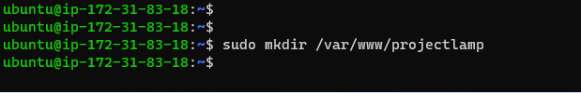

I assign ownership of the directory with your current system user:

sudo chown -R $USER:$USER /var/www/projectlamp



Then, I created and opened a new configuration file in Apache’s sites-available directory using your preferred command-line editor. Here, we’ll be using vi

sudo vi /etc/apache2/sites-available/projectlamp.conf

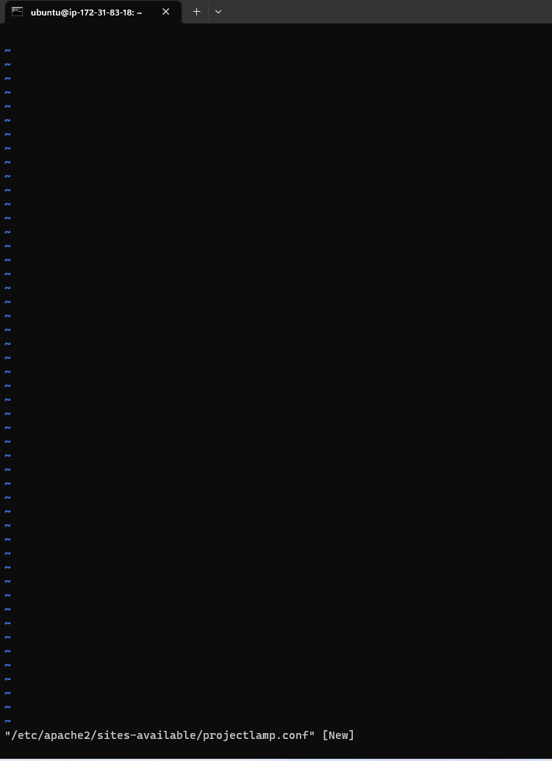

I pasted the below in the blank file and save.

<VirtualHost *:80>

ServerName projectlamp

ServerAlias www.projectlamp

ServerAdmin webmaster@localhost

DocumentRoot /var/www/projectlamp

ErrorLog ${APACHE_LOG_DIR}/error.log

CustomLog ${APACHE_LOG_DIR}/access.log combined

</VirtualHost>

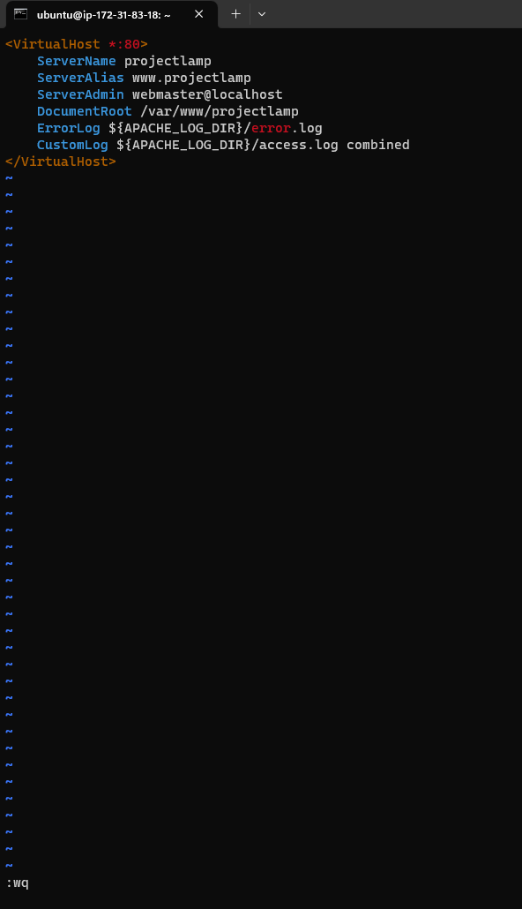

I use the ls command to show the new file in the sites-available directory

sudo ls /etc/apache2/sites-available

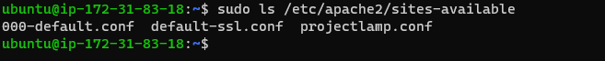

I used a2ensite command to enable the new virtual host:

sudo a2ensite projectlamp

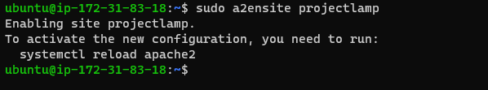

I disabled Apache’s default website use a2dissite command , type:

sudo a2dissite 000-default

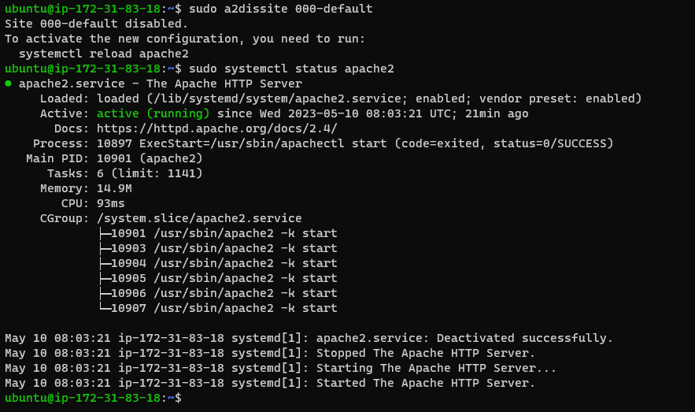

To make sure your configuration file doesn’t contain syntax errors, run:

sudo apache2ctl configtest

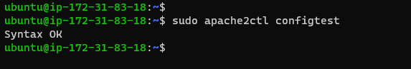

To reload Apache so these changes take effect:

sudo systemctl reload apache2

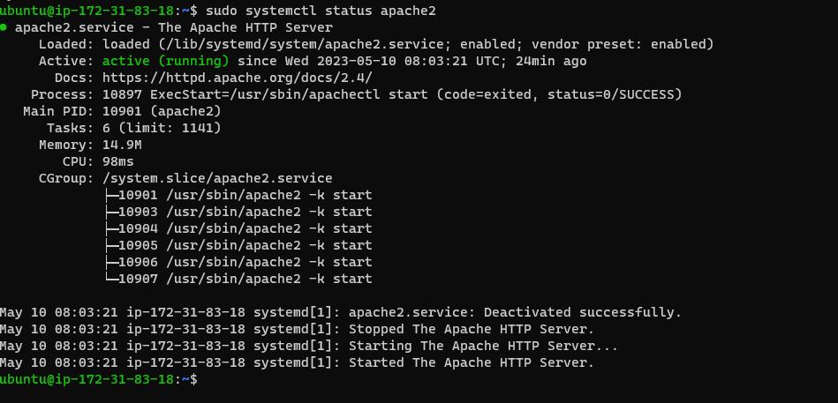

My new website is now active, but the web root /var/www/projectlamp is still empty. Create an index.html file in that location so that we can test that the virtual host works as expected:

sudo echo 'Hello LAMP from hostname' $(curl -s http://http://52.54.249.245/latest/meta-data/public-hostname) 'with public IP' $(curl -s http://http://52.54.249.245/latest/meta-data/public-ipv4) > /var/www/projectlamp/index.html



I went to my browser and try to open your website URL using IP address:

<http://52.54.249.245:80>

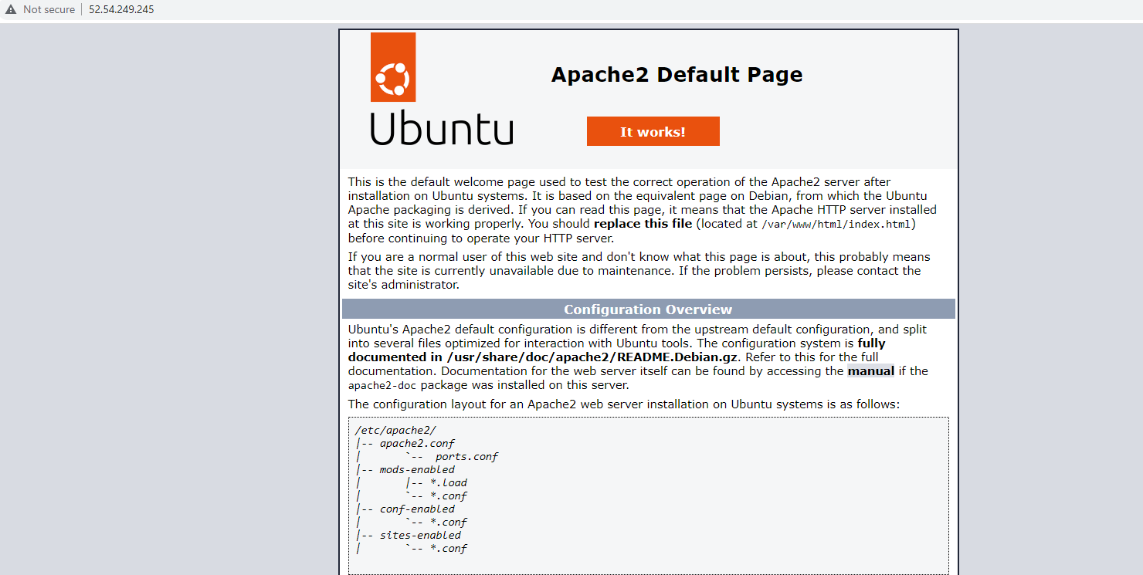

**STEP 5: ENABLE PHP ON THE WEBSITE**

In case I want to change this behavior, i’ll need to edit the /etc/apache2/mods-enabled/dir.conf file and change the order in which the index.php file is listed within the DirectoryIndex directive:

sudo vim /etc/apache2/mods-enabled/dir.conf

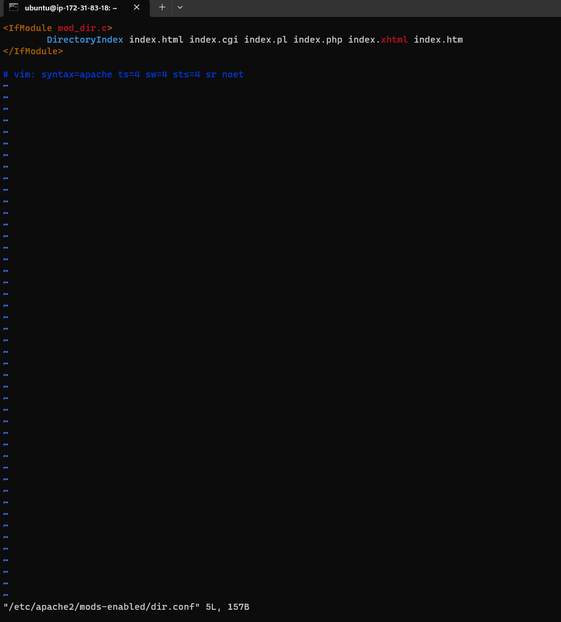

Then

#Change this:

#DirectoryIndex index.html index.cgi index.pl index.php index.xhtml index.htm

#To this:

DirectoryIndex index.php index.html index.cgi index.pl index.xhtml index.htm

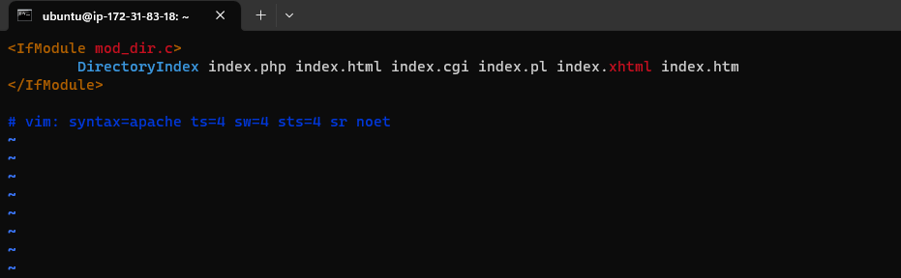

After saving and closing the file, you will need to reload Apache so the changes take effect:

sudo systemctl reload apache2

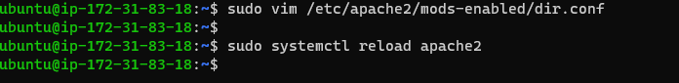

I created a new file named index.php inside your custom web root folder:

vim /var/www/projectlamp/index.php

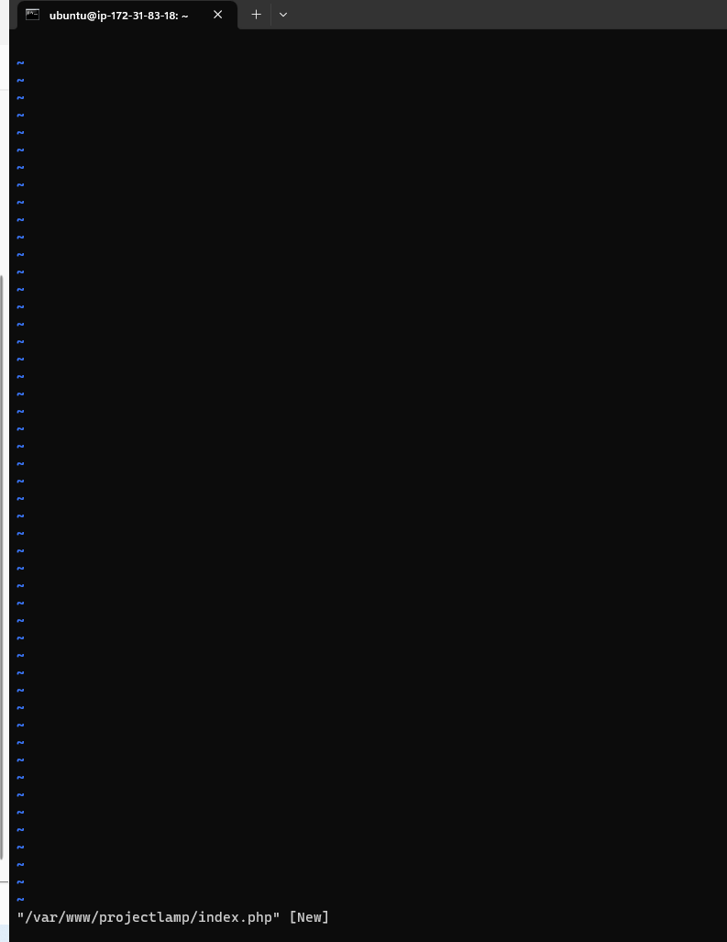

I added the following text, which is valid PHP code, inside the file:

<?php

phpinfo();

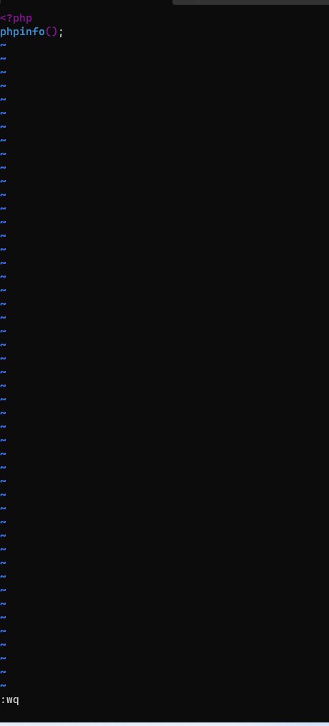

After reloading my browser, I got

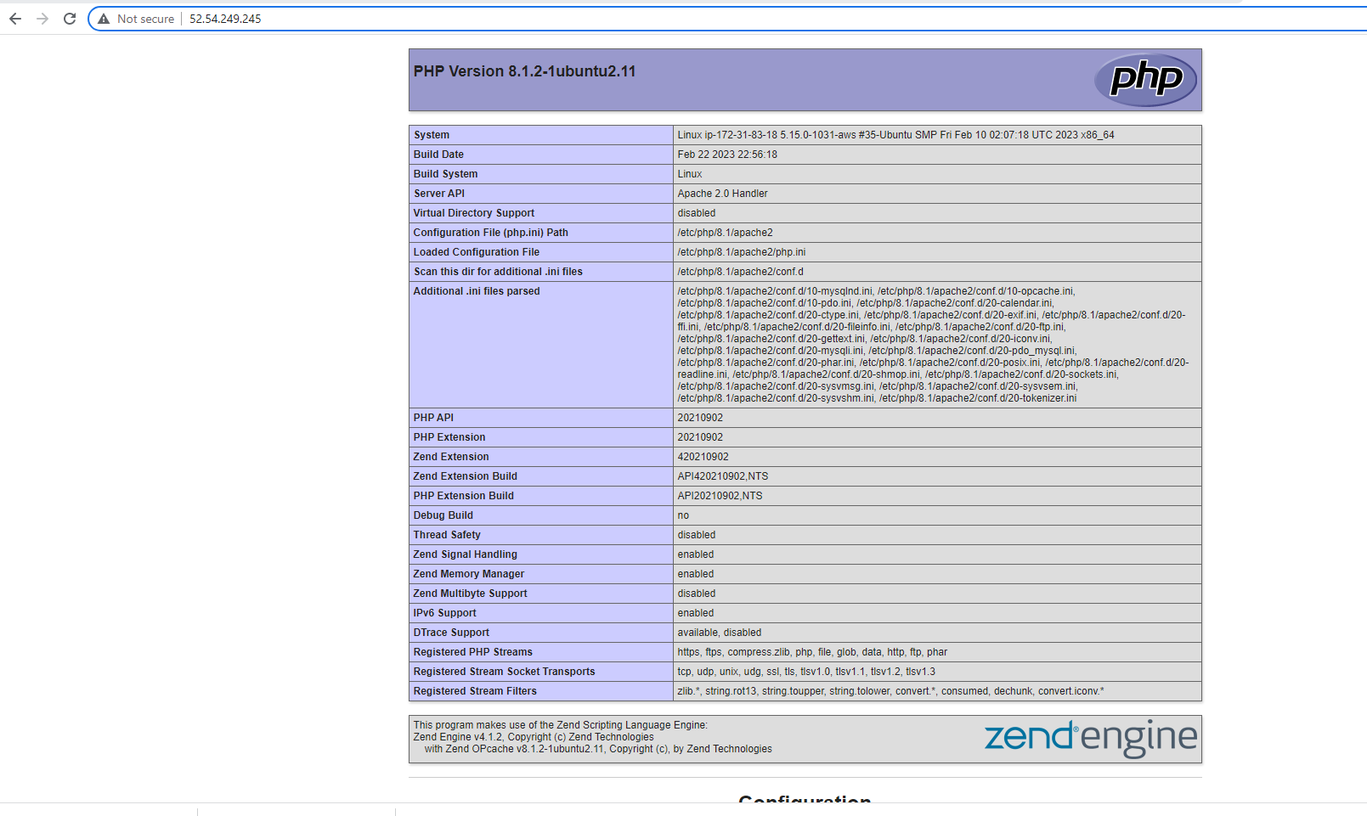

After checking the relevant information about your PHP server through that page, it’s best to remove the file you created as it contains sensitive information about your PHP environment -and your Ubuntu server. You can use rm to do so:

sudo rm /var/www/projectlamp/index.php

